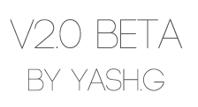

Table of Contents

* The Game - pg. 3
* User Interface - pg. 4
* Basic Controls - pg. 8
* Game Modes - pg. 9
* Credits - pg. 11



Collateral: The Game

Inspired by the arcade generation of the 90’s and the birth of the first digital arcade games, collateral is a new take on the 2D arcade shooter genre. It bears a very simplistic approach, with no more than four buttons to press at any time. The inspiration for the game came from a variety of sources but the feature that sets this game apart is that it is fun and engaging yet difficult.

Collateral is all about fast-paced, high octane smashing action. Smash different colored blocks to rack up points and combos, but beware… each block behaves differently! Rack up enough combos and you get collateral: a bomb that wipes blocks off the screen for points!

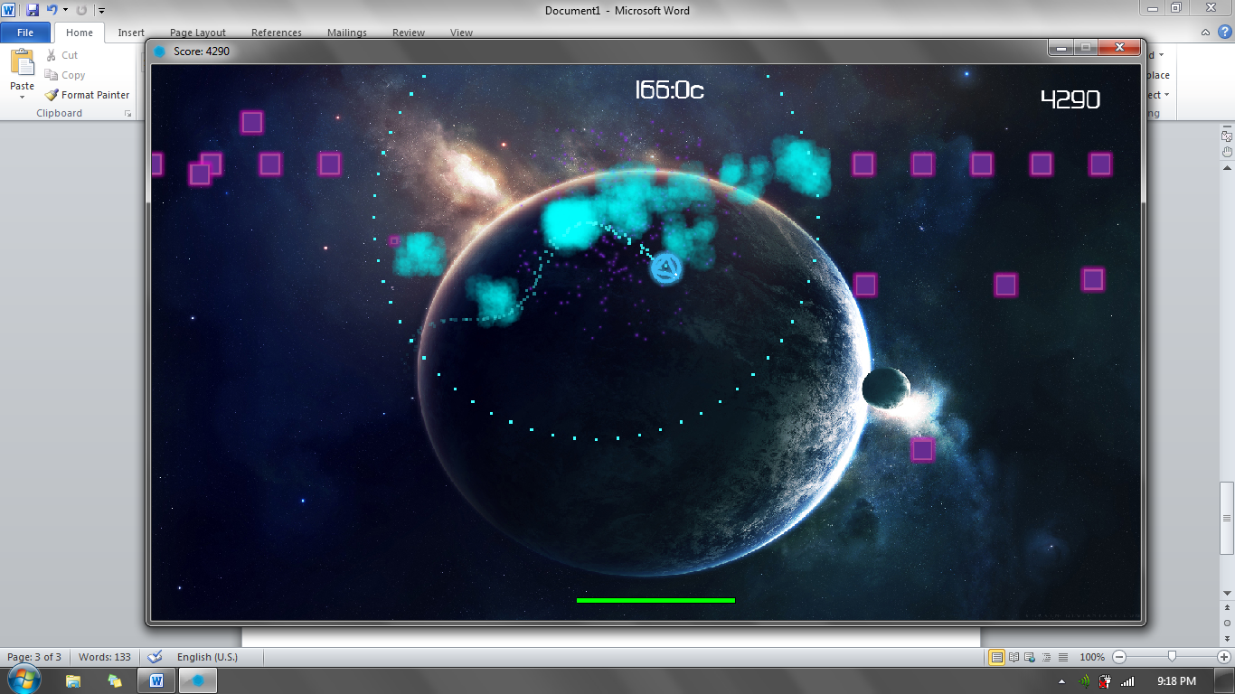

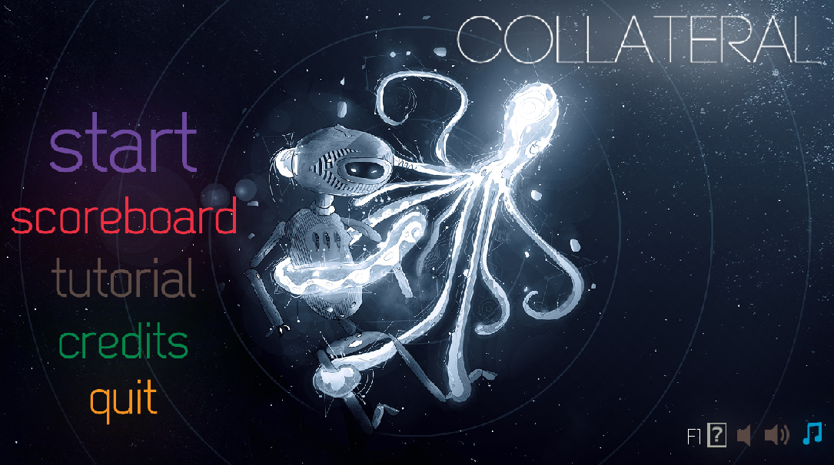User Interface

This is the home screen. To get navigation help at any time, the F1 button can be pressed as indicated on the bottom right. The speaker and music buttons are not compatible and have not been coded. All navigation buttons correspond to numbers on the number pad. The number pad is on the far right of a keyboard. (Make sure Num Lock is on) The start screen will be covered a bit later, but let us start with the scoreboard screen.

The scoreboard displays fifteen scores of players or teams who have played the game. The scores are arranged from highest to lowest. The green box on the top left represent the all-time highs. It shows the most number of blocks destroyed, the fastest time, the highest combo, the most collaterals collected and the highest score of all time. (Note that the fastest time is not recorded for arcade mode) The scores can be reset by pressing the number 1. The green section cannot be reset however.

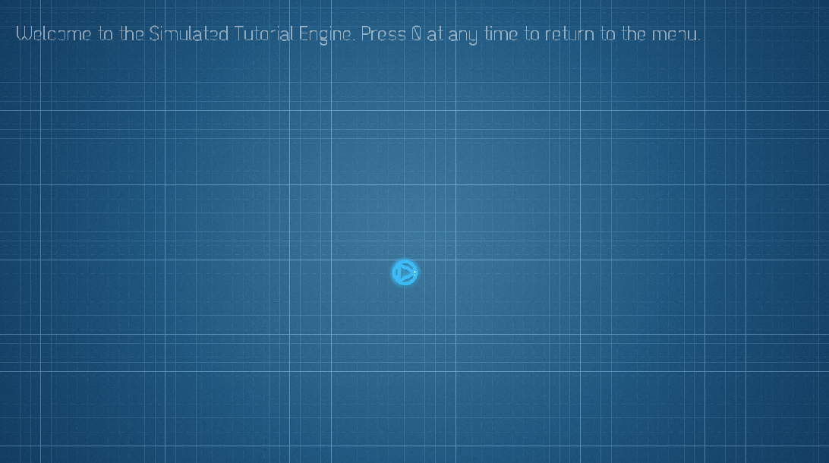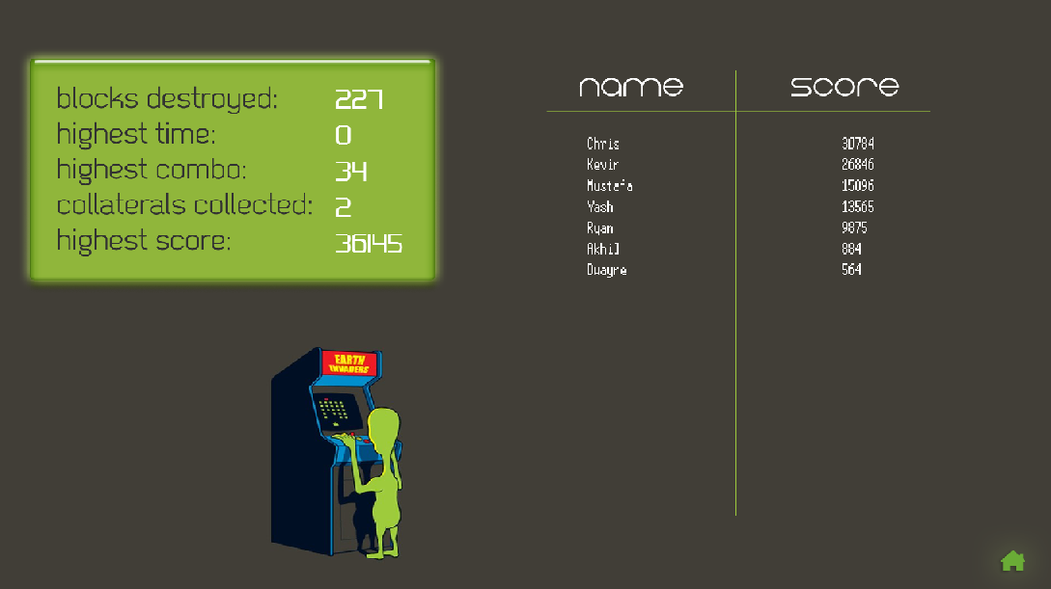To return back to the home screen from any window, press the number 0.

Next up is the tutorial. It can be accessed by pressing the number 3. The tutorial is approximately 2 minutes long and it covers the very basics of playing the game. It does not cover the powers of the various blocks and the user interface however.

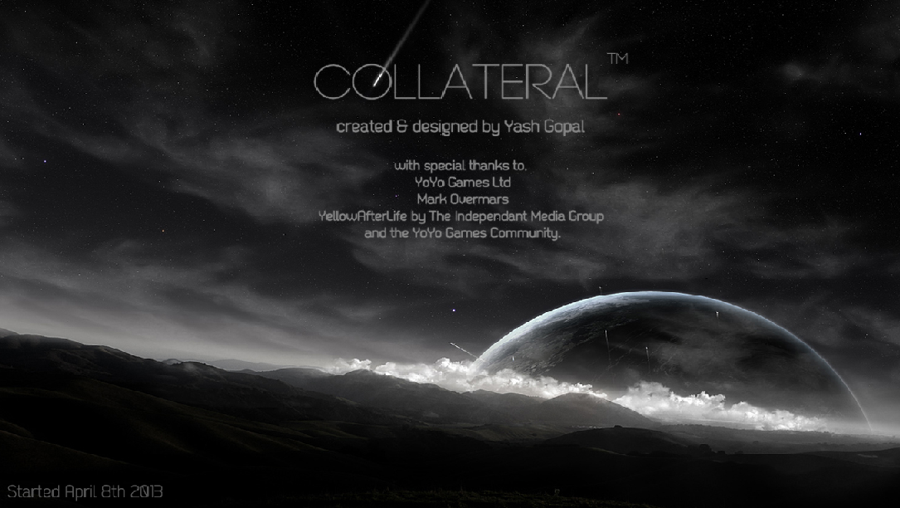Next up is the credits menu. This is a non-interactive screen that can be accessed by pressing the number 4.

The last button on the home screen is the quit button which exits the game. It can be done by pressing the number 5.

The start screen is the intermediary menu between the game and the home screen. Here the user has to decide how many players will be playing and what game mode they will be playing.

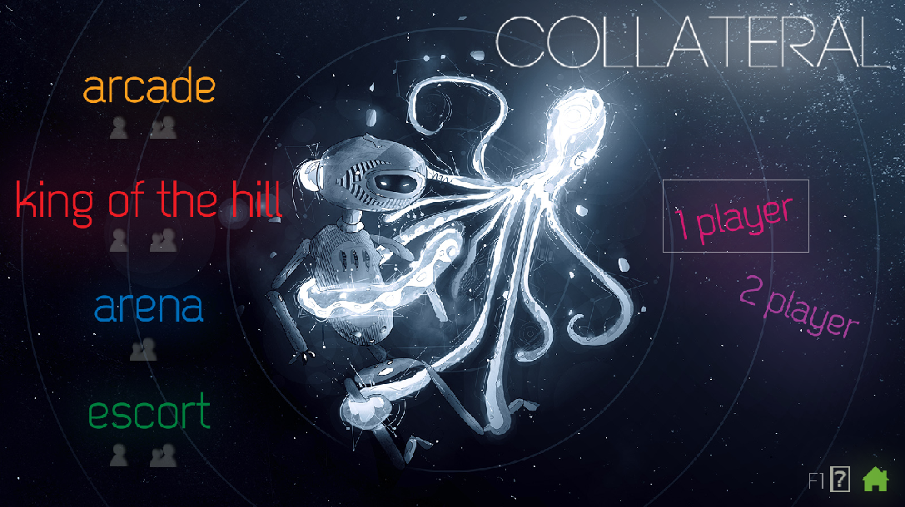

As in before, the navigation help can be accessed anytime by pressing and holding the F1 key and the user can return to the home screen by pressing 0.

The # of players selected is indicated by the white boxes around the texts ‘1 player’ and ‘2 player’. To play as one player, press 5, then choose the appropriate game mode using the number buttons. To play two player, press 6 then choose a game mode. (Only arcade mode is available) The number of players that can play in a game mode is indicated by the user icons beneath the game modes. For example, arcade mode is both single and multiplayer but arena is only multiplayer.



Basic Controls

The controls for collateral are very simple. Note: To get a hands on explanation, use the in-game tutorial.

For single player, the controls are the arrow keys. The up arrow acts like the gas pedal; it has to be held down to move. While holding the up arrow the left and right arrow keys can be used to turn. The back arrow can also be used to decelerate. For multiplayer, the controls are switched. 1st player is mapped to WSAD, while the second player is mapped to the left and right mouse buttons and the left and right arrow key. Due to an IDE and hardware limitation, the arrow keys could not be used. Thus, the second player can accelerate by holding the left mouse button and can use the arrow keys like before to turn.

The spacebar is the collateral button. Press it to use a collateral bomb. The number of collaterals available are displayed near the time, in-game.

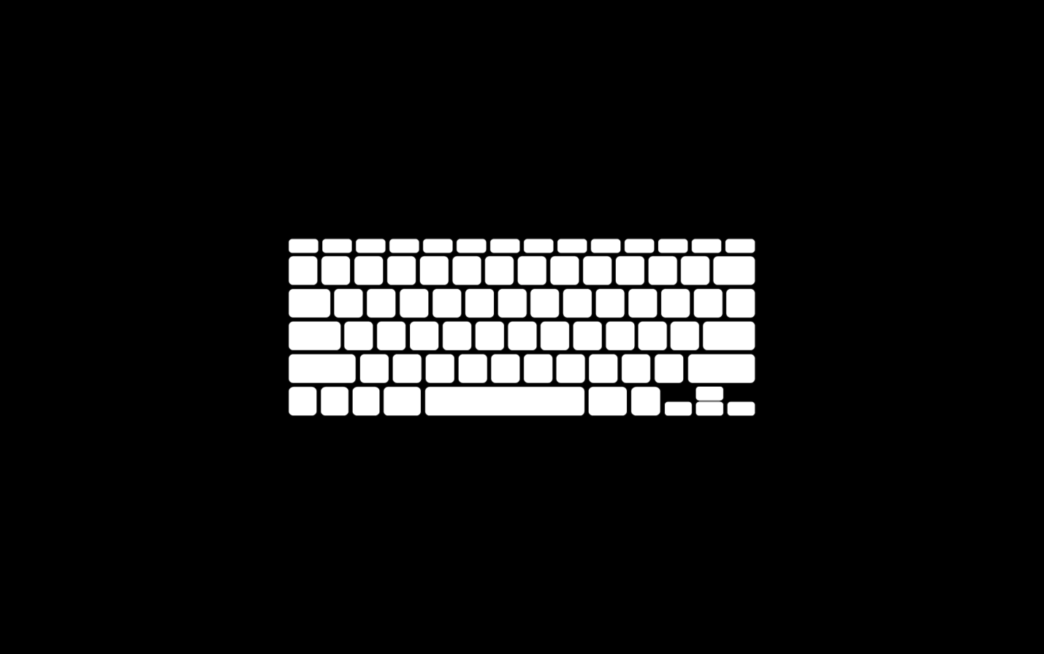

1 Player

2 Player



Game Modes

To reiterate, the only game mode that is currently playable is arcade mode. The other game modes: King of the hill, Arena and escort could not be finished due to time limitations.

# Arcade

The primary objective in arcade mode is to get as many points as possible, within a certain time. The time is shown in seconds in the top middle of the screen. The score is shown on the far right corner and the block specific combos, beneath. Special messages are shown in the top left corner. For example if you have a collateral bomb, the game will display ‘Collateral!’ The number of collateral bombs collected are displayed next to the time. Here, the player has 1 bomb.

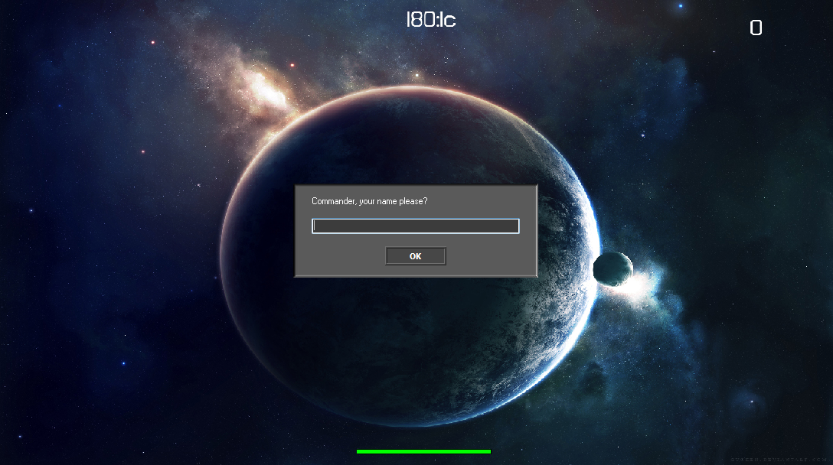

The score collected per smash is displayed right next to the spaceship when you collide. The health bar is on the bottom. Every time the player is hurt, a sound and a visual indicator on the health bar will inform the player. When the game starts, the user is asked for a name. Type in a name and press enter. If two players are playing, a team name is required.

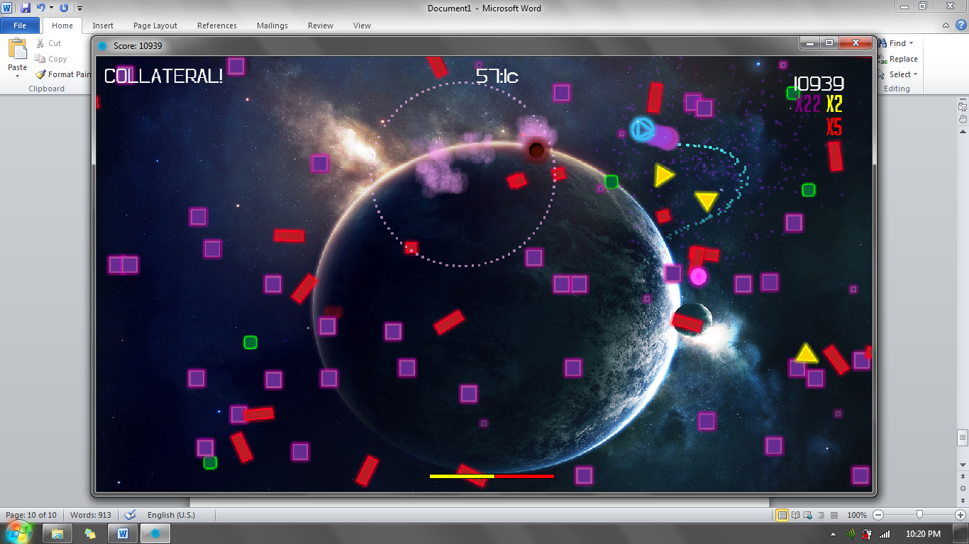

Each color block has different powers. The purple block is harmless and grants 5 points. The green block grants 10 points each but sometimes leaves behind smaller green blocks that don’t move. These are dangerous as they do damage and reduce a players score when collided with. The yellow triangles shoot out smaller triangles periodically at random times. The smaller triangles hurt, but the main parent can be destroyed for 15 points. The red rectangles spawn smaller red squares when they come in contact with another block. These squares hurt as they travel to the black hole that moves around the screen. The black hole absorbs 5 of these squares until it releases a new red rectangle. So it’s better to kill the rectangles before they multiply out of control! The rectangles are worth 10 points. And lastly, there’s the pink sphere which is a time bomb. It follows a player very quickly, but slows down to a stop eventually. Once it stops it counts down for 5 seconds. If the bomb is hit when it is moving the explosion is bigger and it causes a lot of damage. The bomb can be defused during countdown by smashing it for 100 points. It also gives the player a small health bonus.

As explained in the in-game tutorial, when blocks are smashed, smaller particles representing the color you smashed follow the player. Each particle represents a x1 combo, therefore the more you collect, the higher your combo. These particles can be destroyed by any kind of bomb, including the collateral.

# Credits

Created and designed by Yash Gopal.

(The space backgrounds and music is not my property but all the menus and sprites were custom designed by me)

With special thanks to,

YoYo Games Ltd

Mark Overmars, GML Tutor

YellowAfterLife by the Independent Media Group

And the YoYo Games Community.

Made for my Grade 12 Computer Science CAT. (April-June 2013)